**Website Hosted On Github Link:**

<https://andrewplum.github.io/CS_360/Labs/Lab_2/Home.html>

1a Home.html: 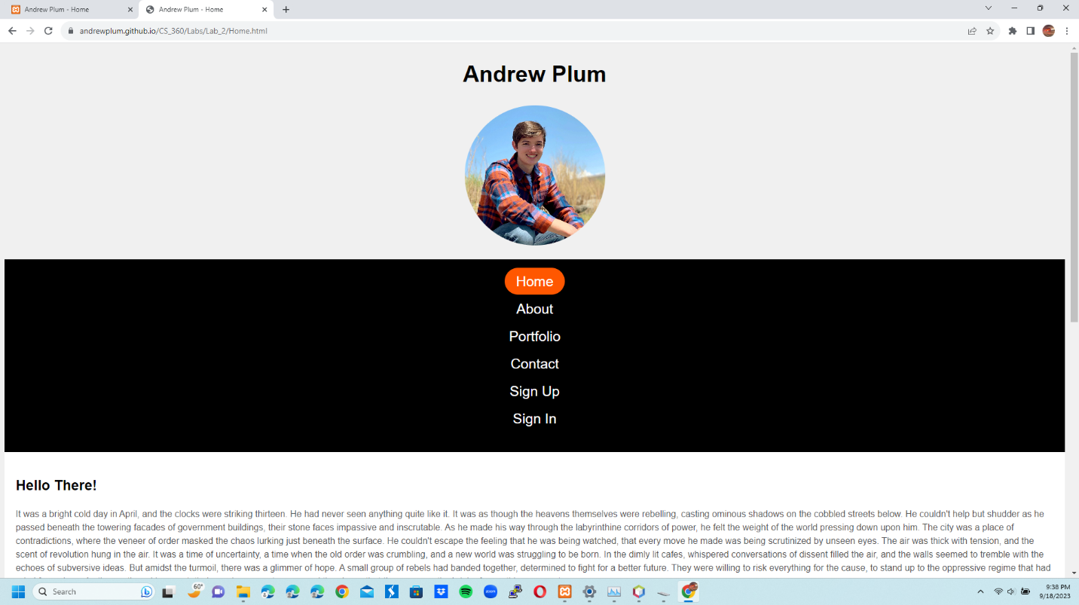

1b Home.html:

2a About.html:

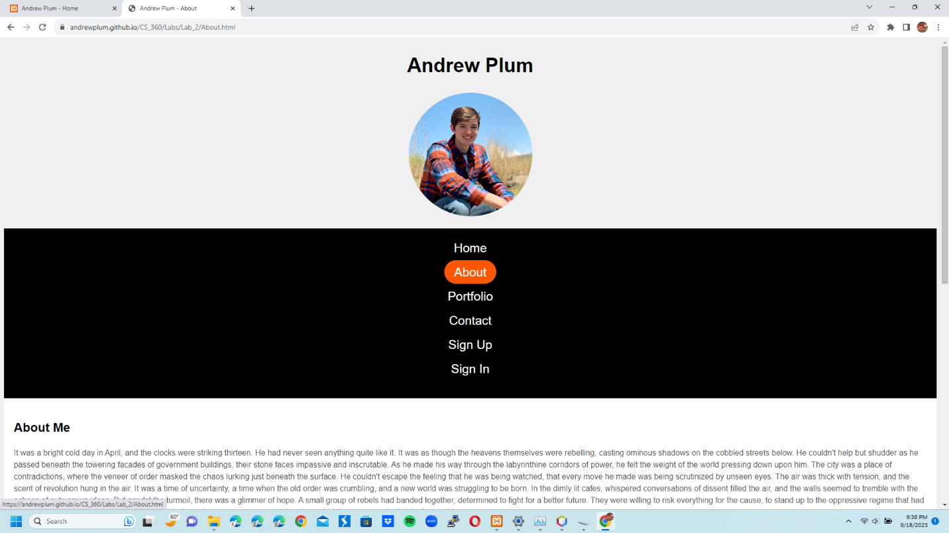

2b About.html: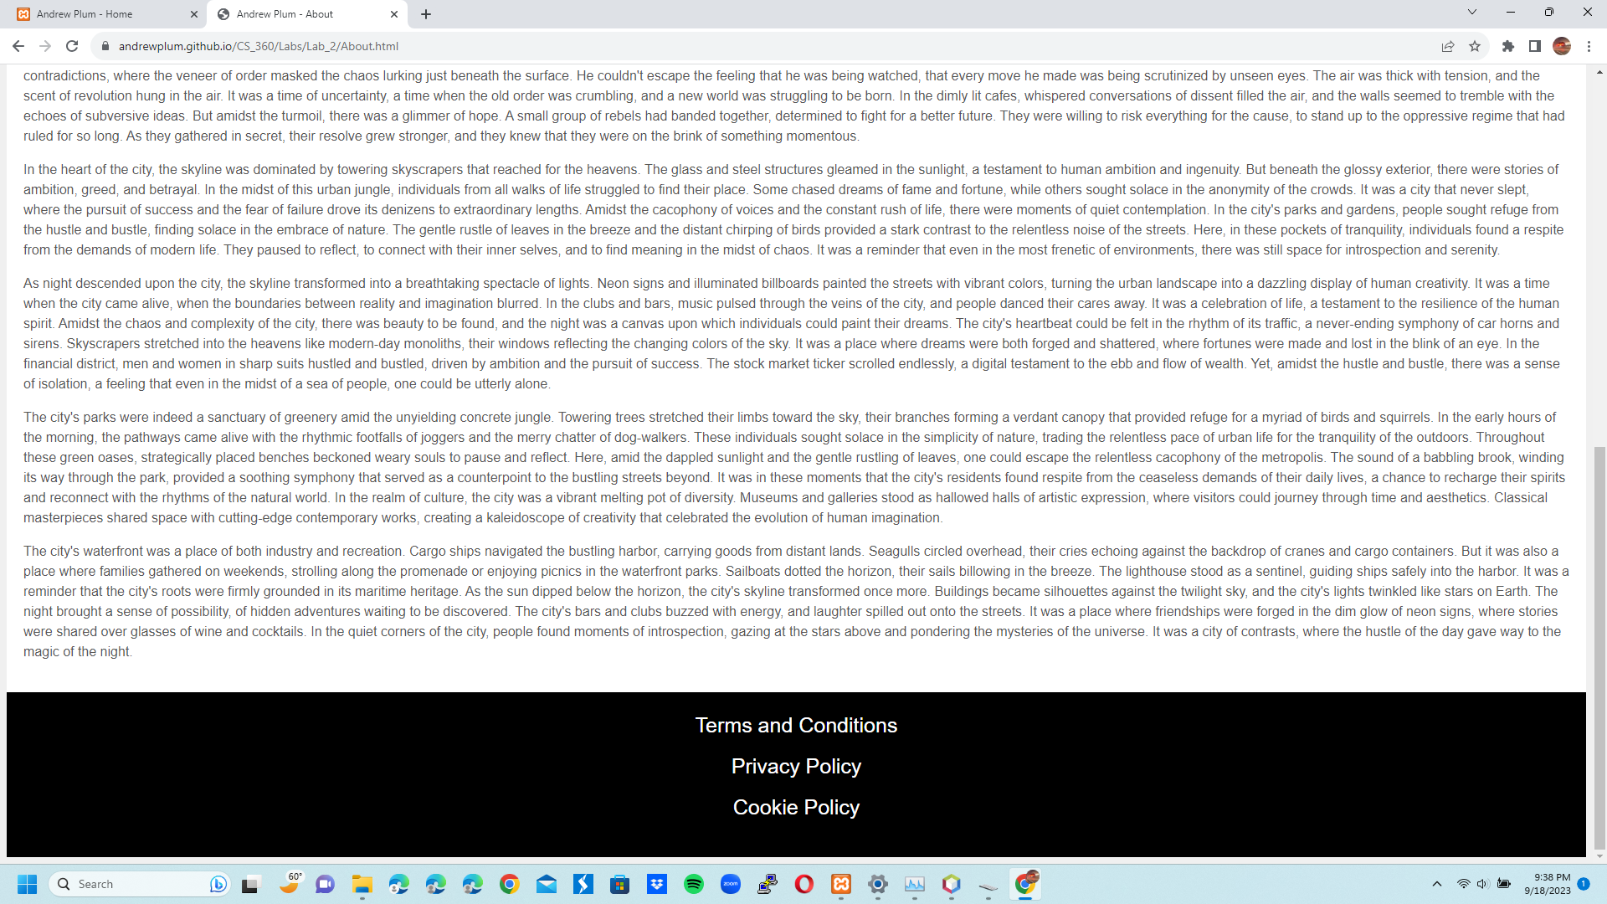

3a Portfolio.html: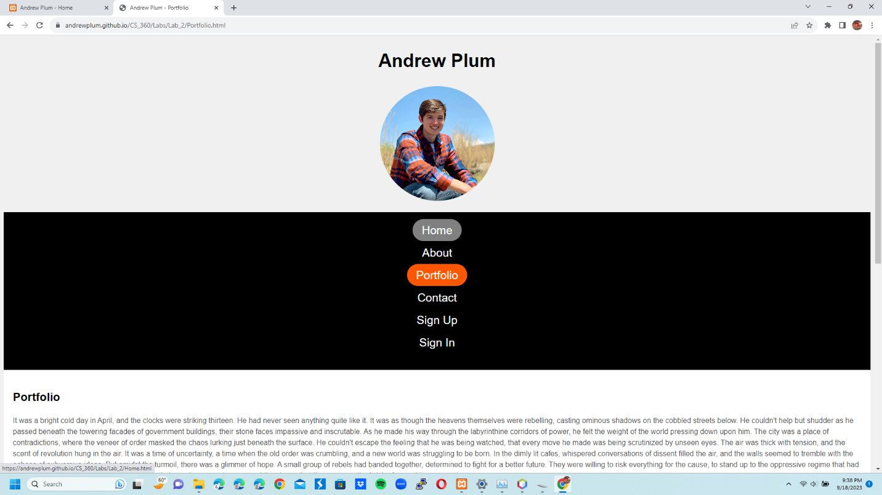

3b Portfolio.html: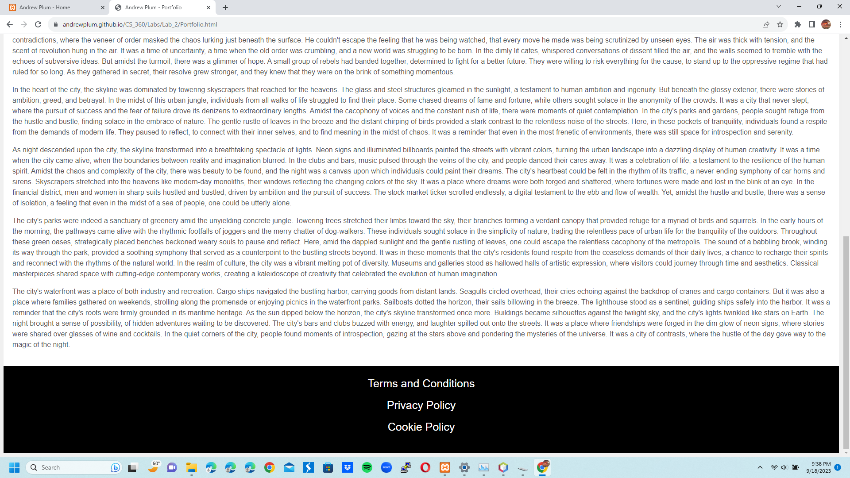

4a Contact.html: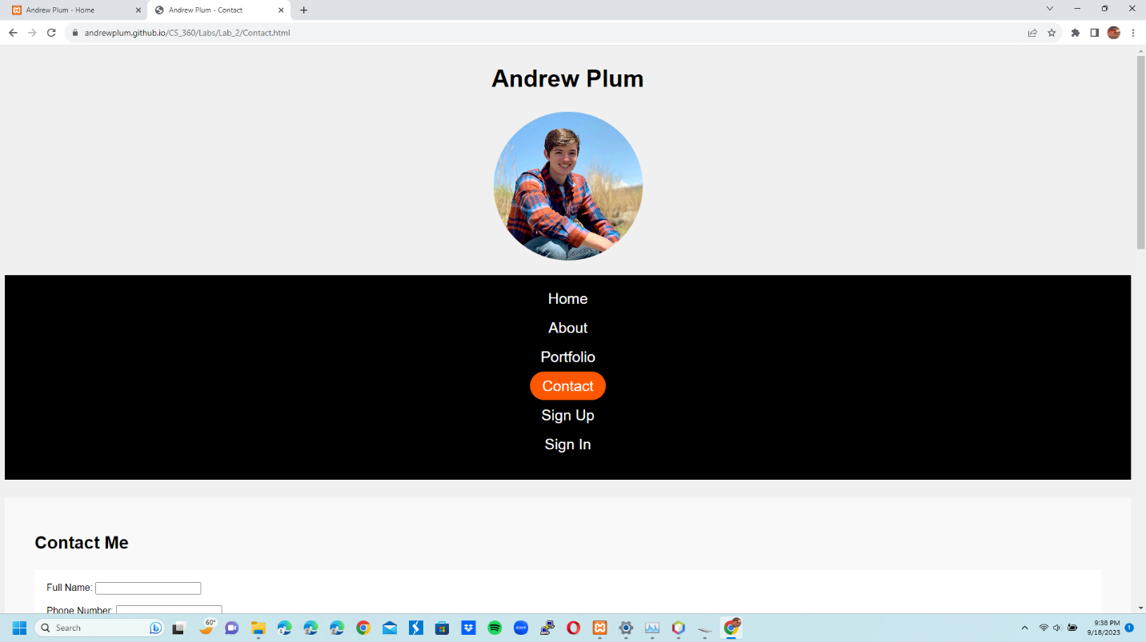

4b Contact.html: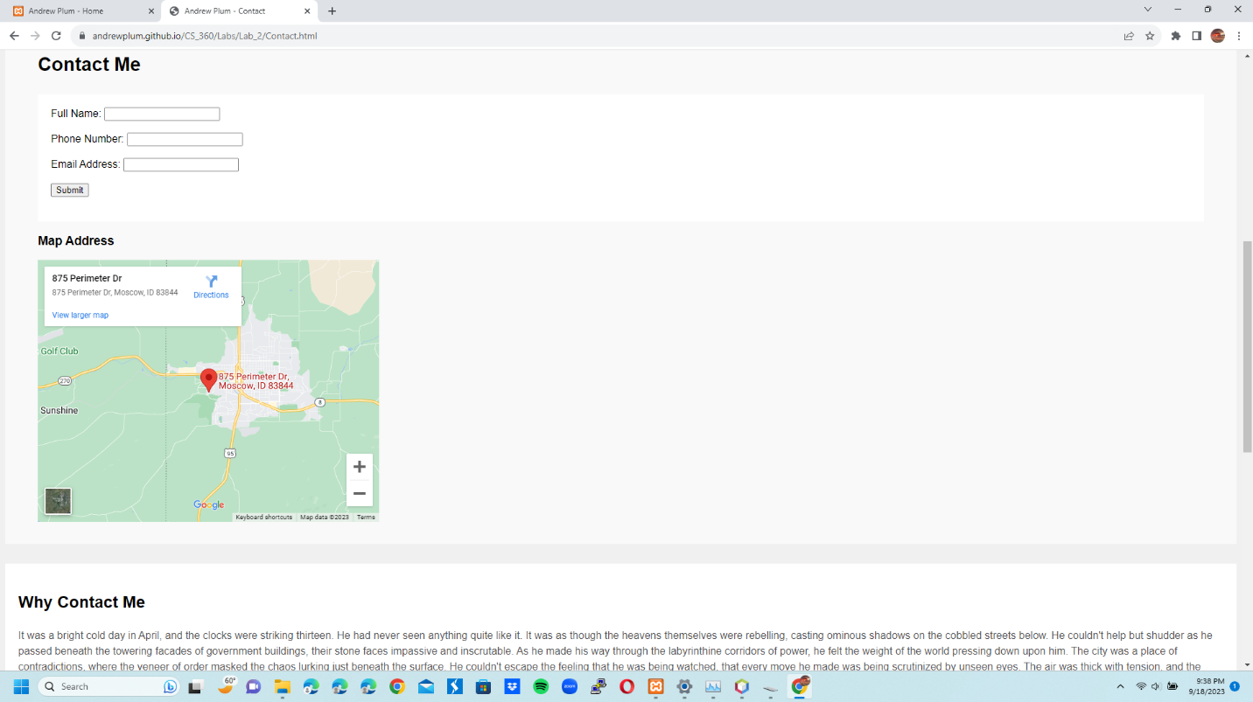

4c Contact.html: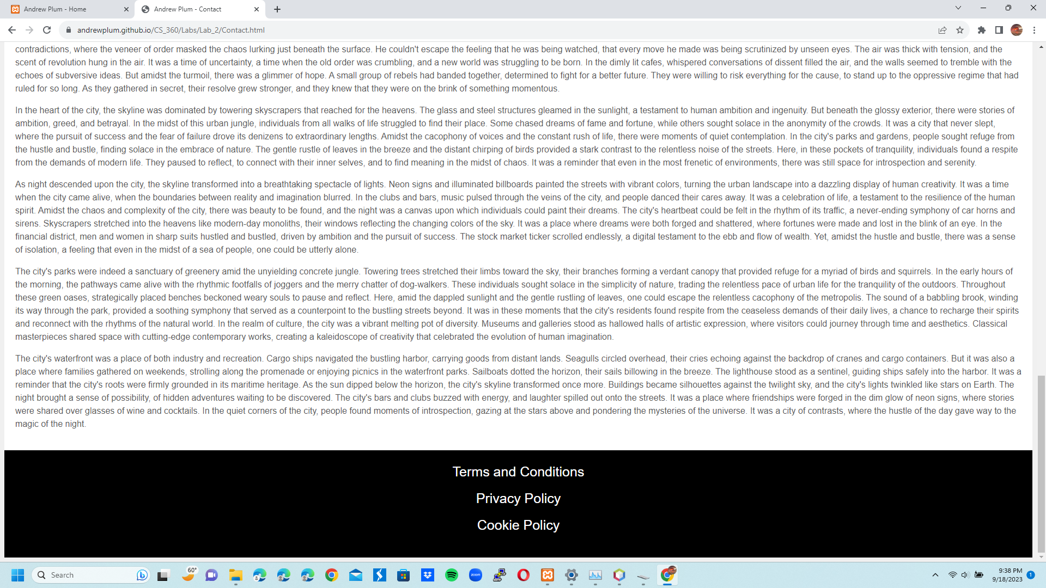

5a Sign_Up.html: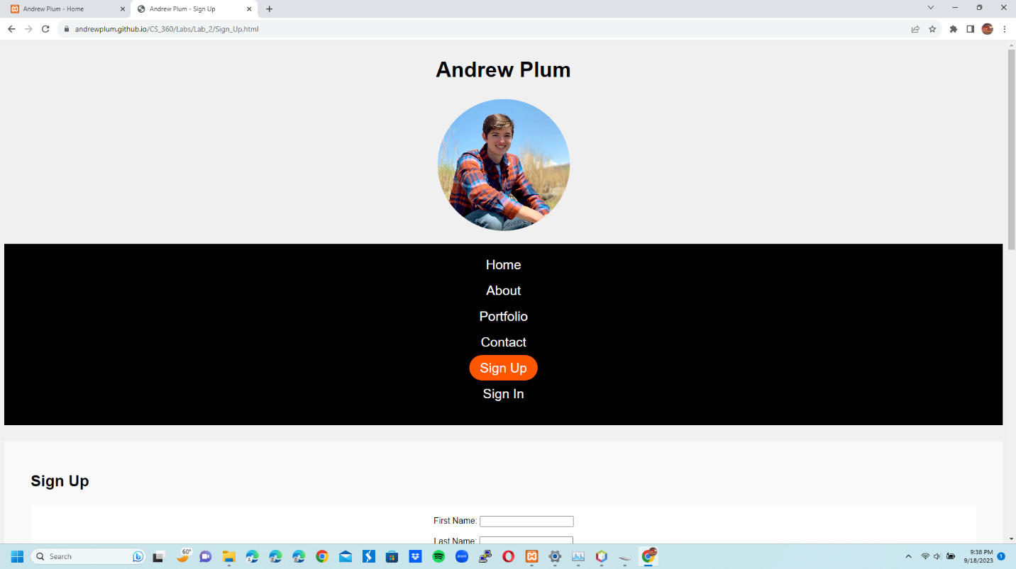

5b Sign_Up.html: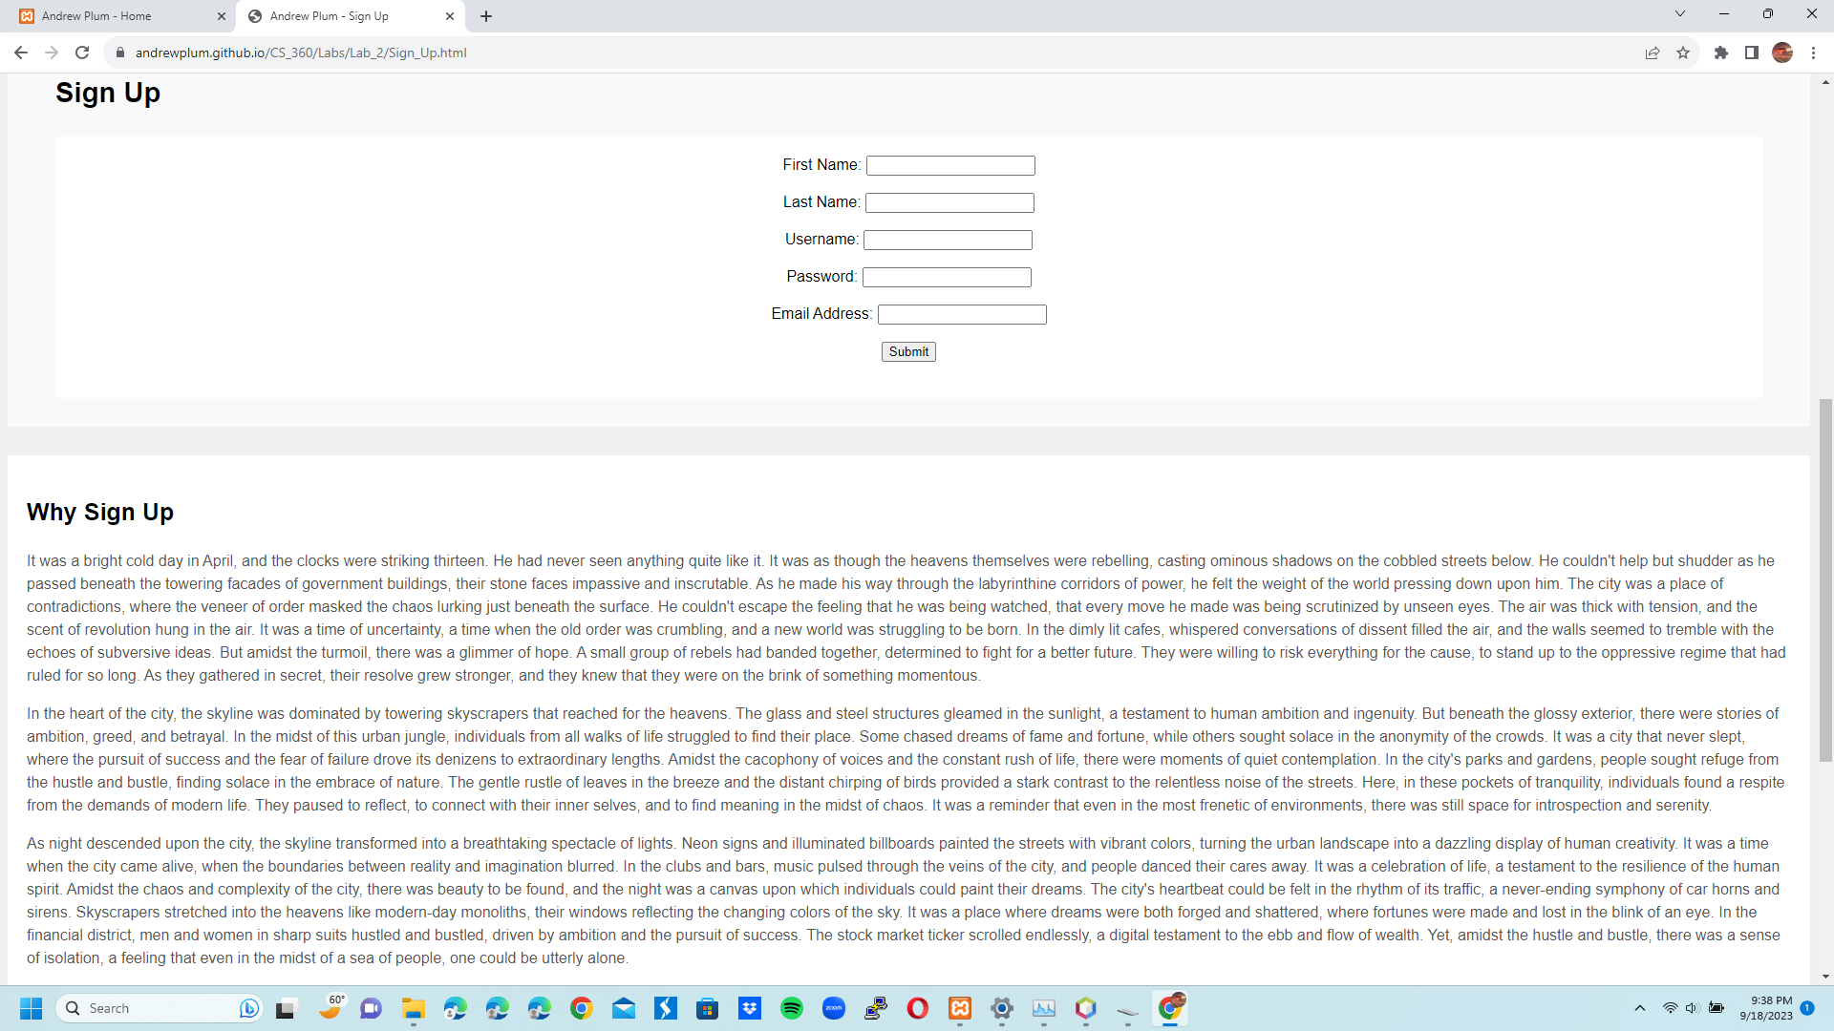

5c Sign_Up.html: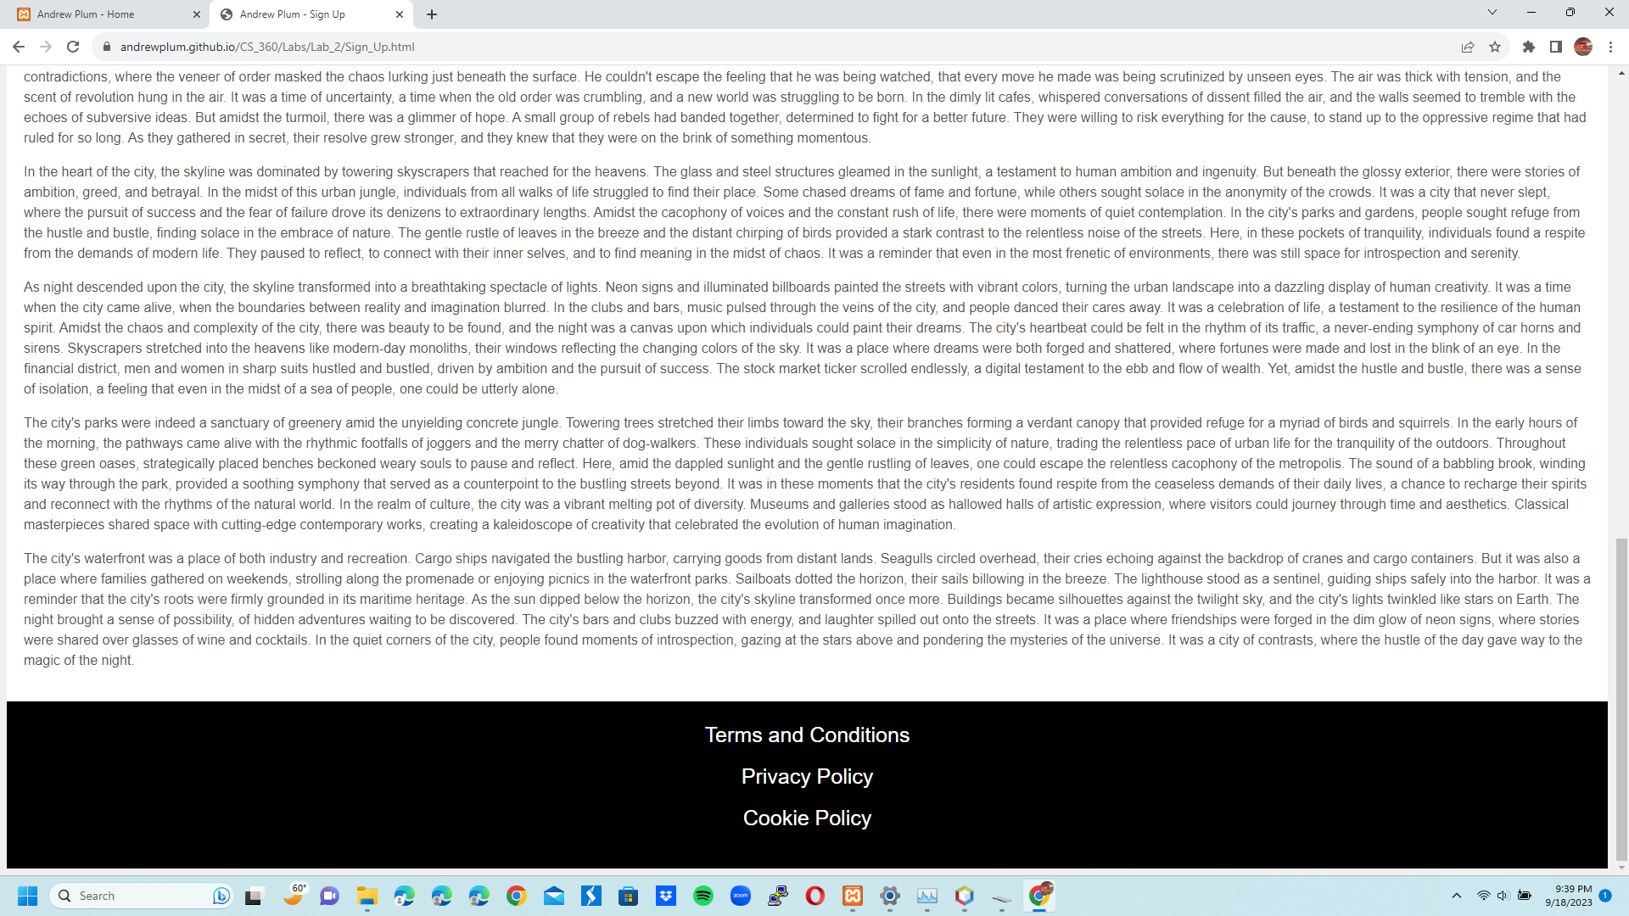

6a Sign_In.html:

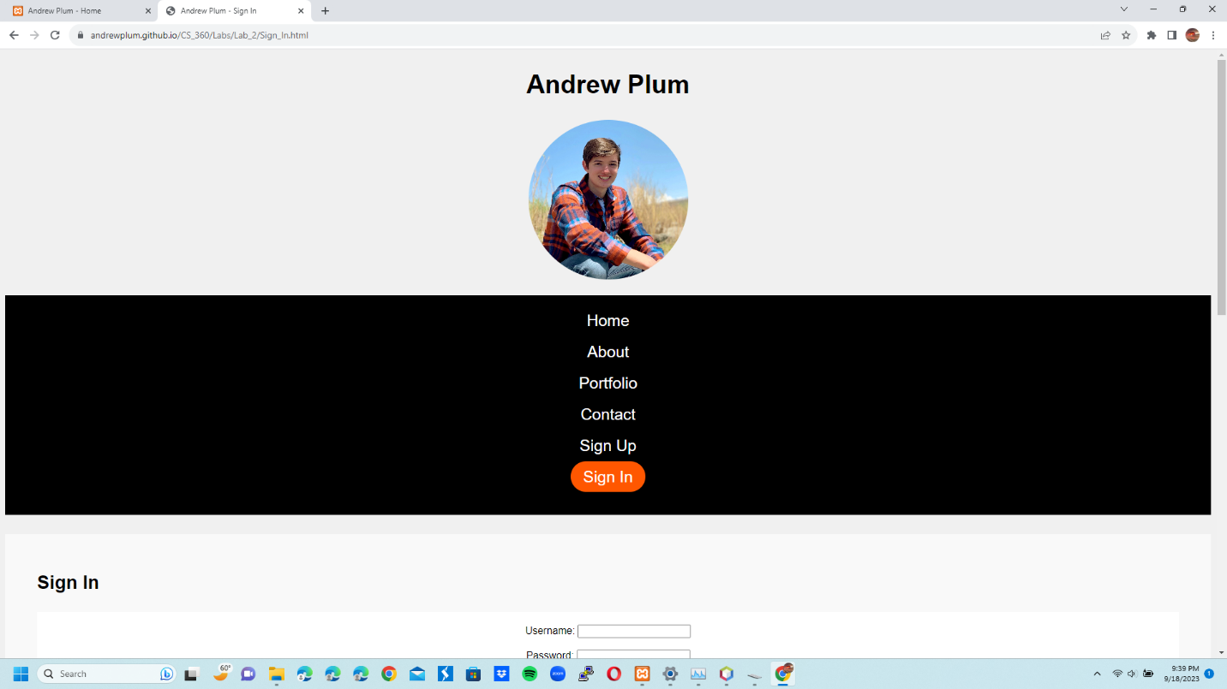

6b Sign_In.html: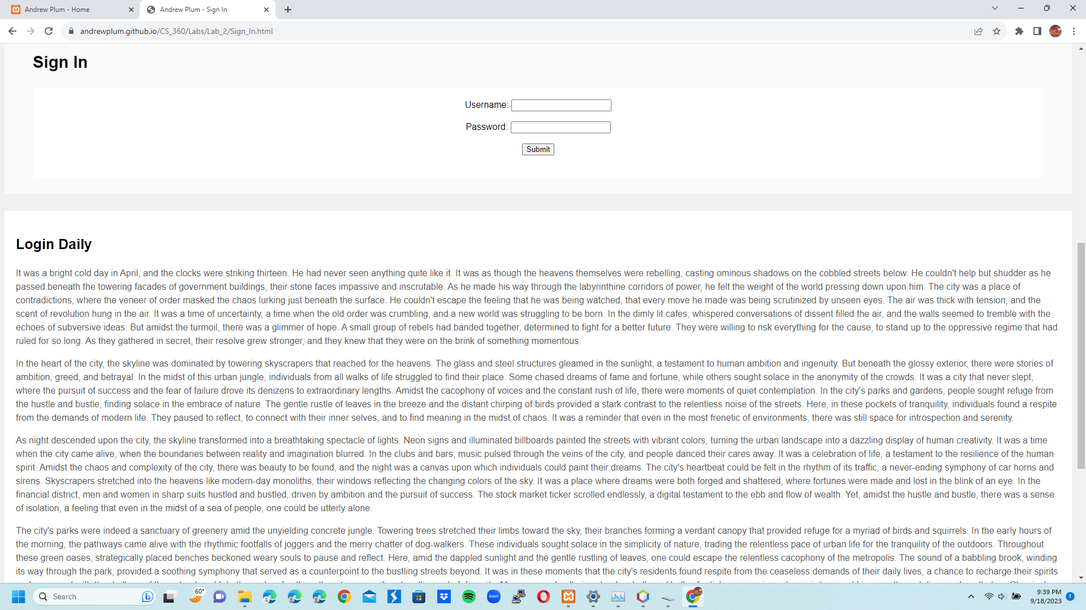

6c Sign_In.html: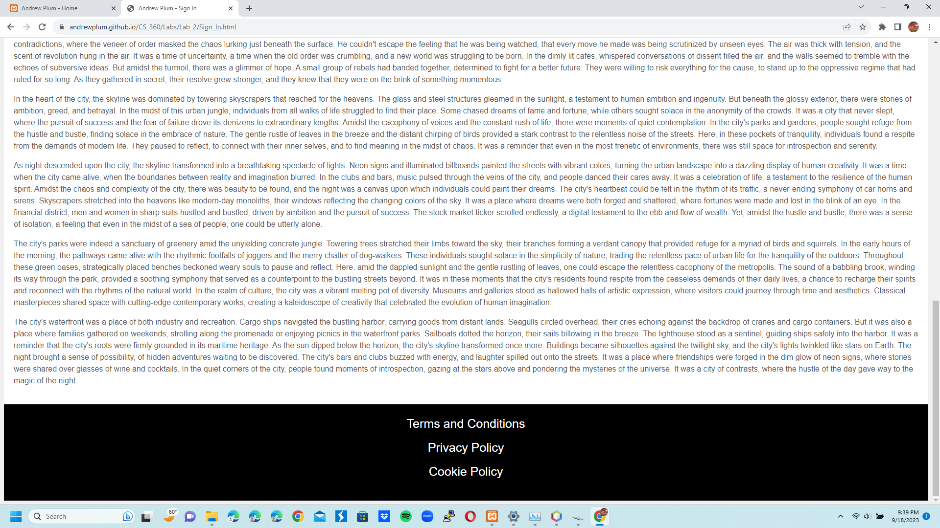

7a Terms_And_Conditions.html: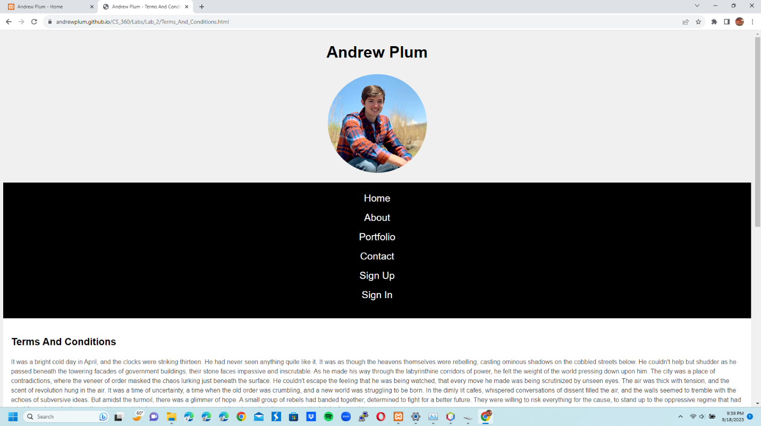

7b Terms_And_Conditions.html: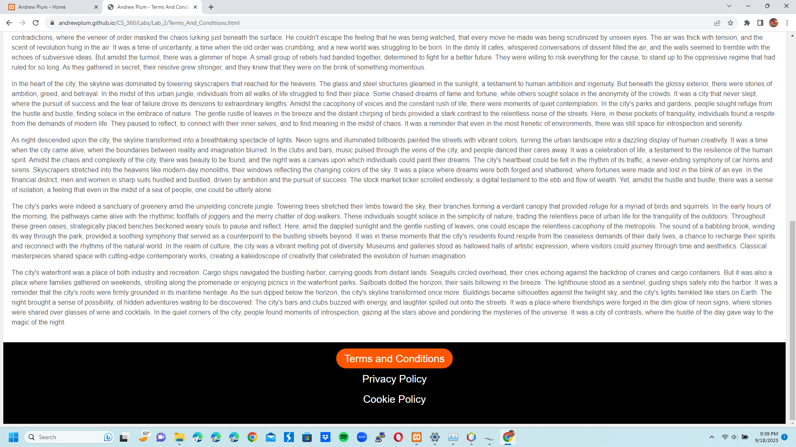

8a Privacy_Policy.html: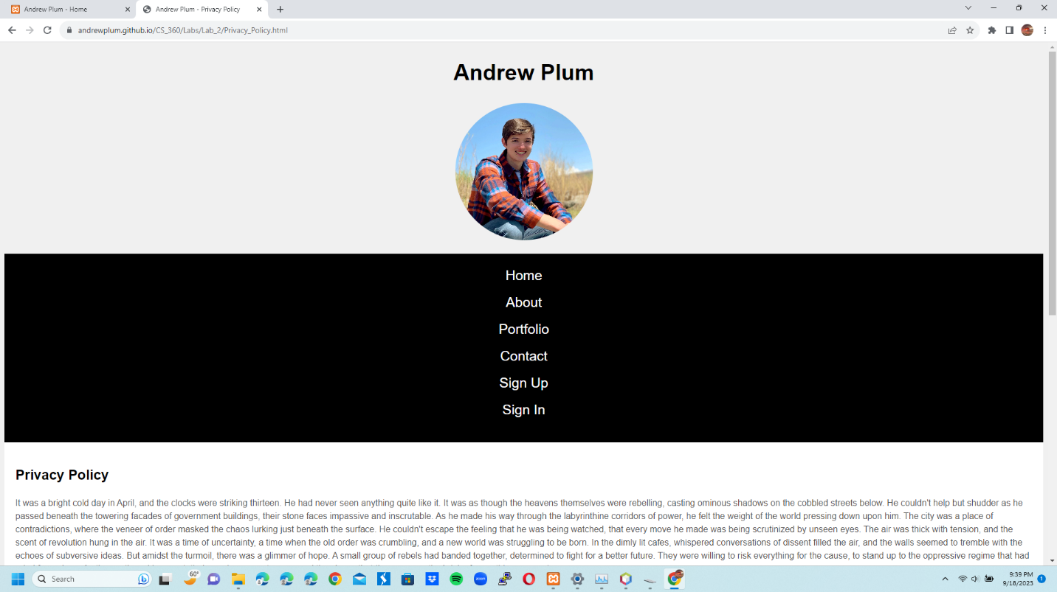

8b Privacy_Policy.html: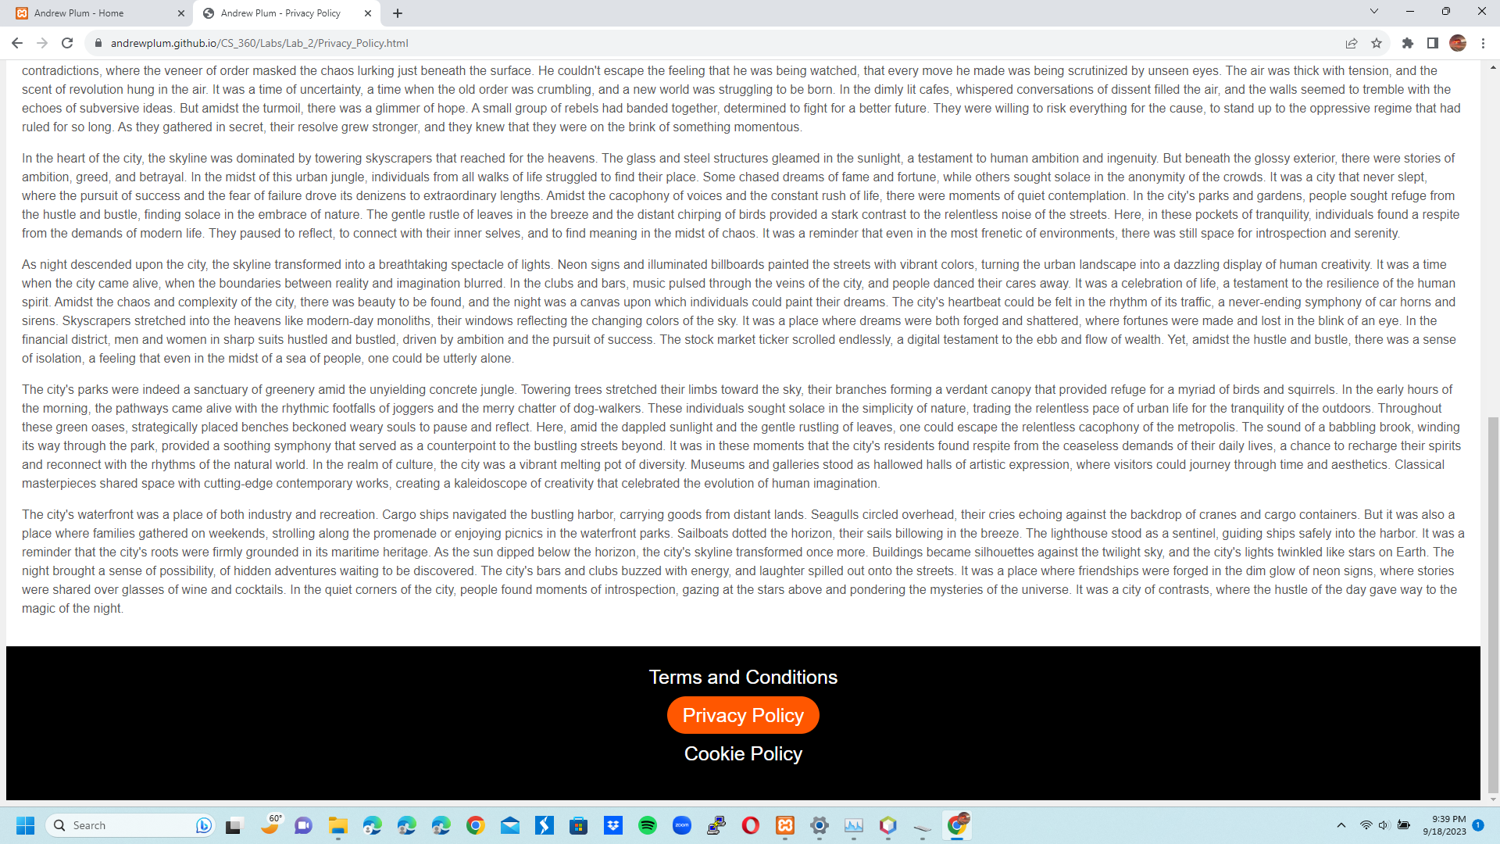

9a Cookie_Policy.html: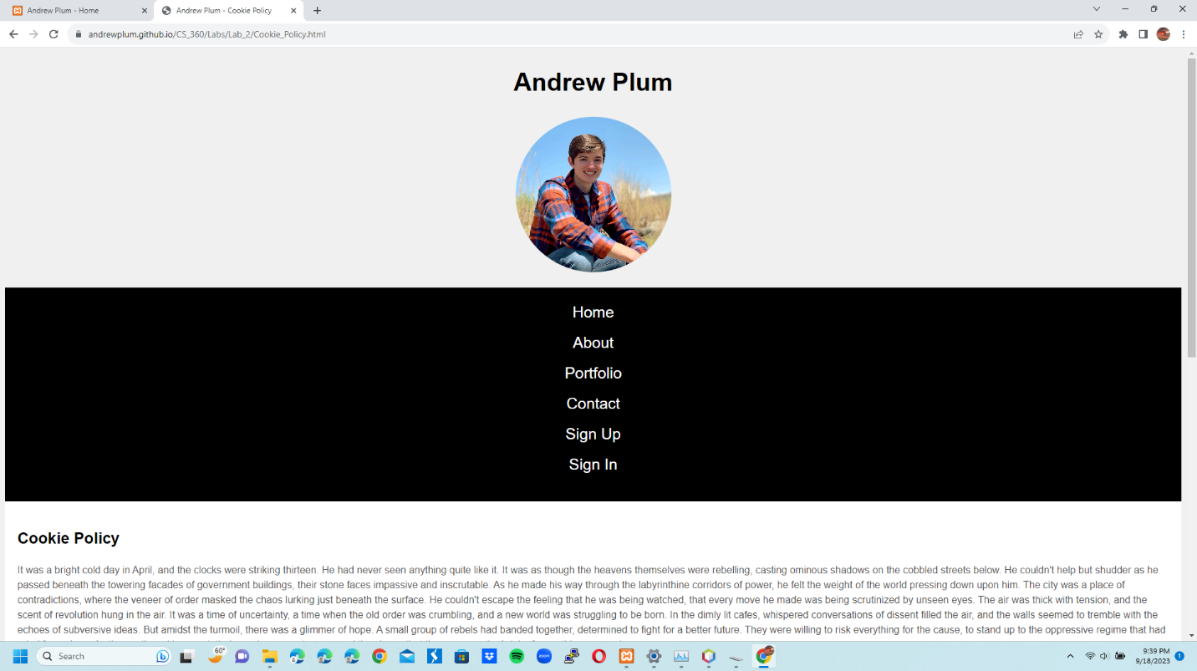

9b Cookie_Policy.html: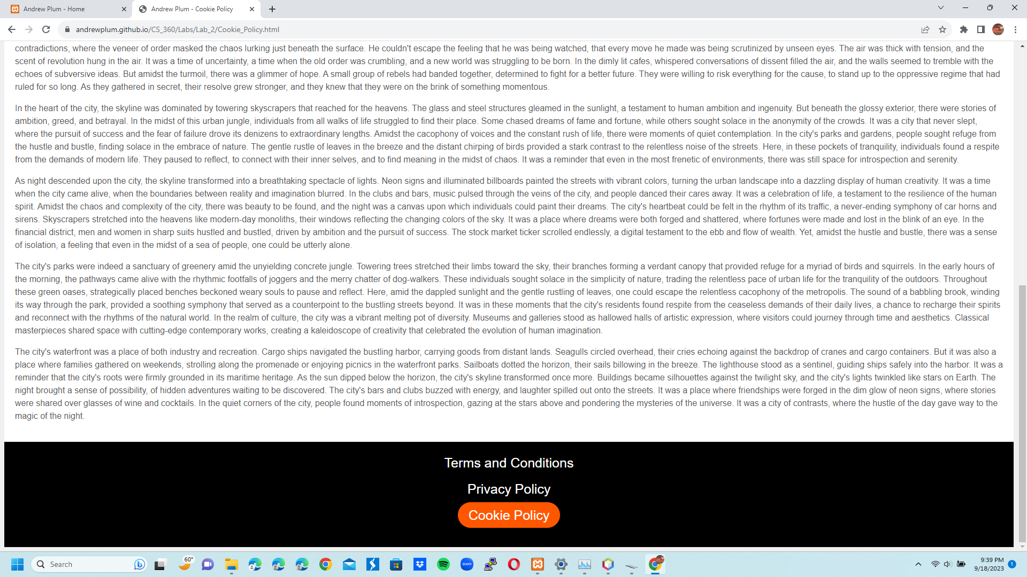

**Website Hosted On Github Link:**

<https://andrewplum.github.io/CS_360/Labs/Lab_2/Home.html>